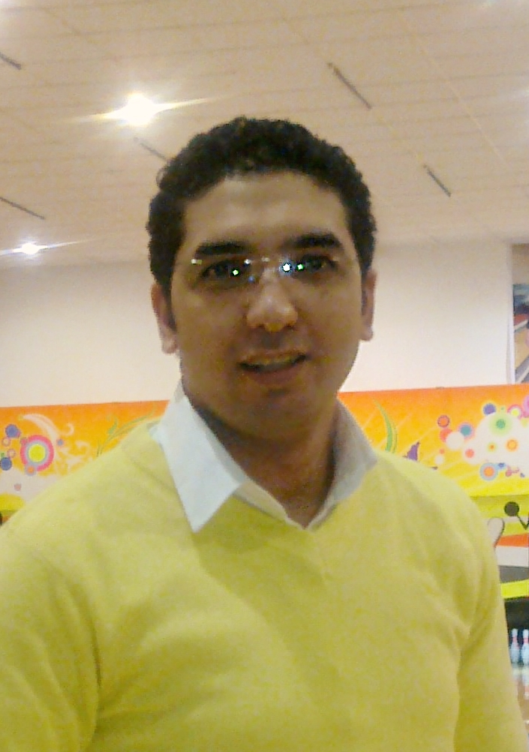

Khaled Mondi Al-Gebaly Agha
22, Elquds Elarabia St, El-haram ,Giza, Egypt
E-Mail: khaleddd8333@gmail.com

OBJECTIVE
Achieving my own career goals by obtaining a challenging position in multi-national or local institution where opportunities for learning and scope of rapid growth and development exist.
EDUCATION

Bachelor of Oral & Dental Medicine
June 2007, Faculty of Dentistry, October 6 University.
- Accumulative Graduation Grade : Excellent With Honor rank – 89.5 %.

Master Degree in Operative Dentistry.
- Faculty of Dentistry, Cairo University.
- Title:
(Effect of Tooth brushing techniques on surface roughness of different cervical resin composite restorations).
- Under Supervision of Dr. Mohsen Abi-El-Hassan.

SKILLS

Computer:
- Competent user of Microsoft Word, Excel, and PowerPoint, Internet, E-mail.

Languages Skills:
- Arabic: Mother Language.
- English: Excellent.

Soft Skills:

- Negotiation skills.
- Patient care.
- Excellent Communications Skills.
- Excellent presentation skills.
- Self Motivated.
- Planning and Controlling.
- Working on problem-solving strategies.
- Excellent teaching and deliver information for students.
WORK EXPERIENCE

- September 2014 – Until Now
Assistant lecturer and Staff member,
Department of Operative Dentistry,
Faculty of Dentistry, Nahda University (NUB).

- September 2007 – Until 2011
Demonstrator and Staff member,
Department of Operative Dentistry,
Faculty of Dentistry, October 6 University.

PERSONAL INFORMATION
Date of Birth: July 23th, 1983.
Marital Status: Married.
Military Status: Exempted.
Nationality: Egyptian.
Religion: Muslim.

